Randall C. Crawford
Student ID: 901012194
Email: r.crawford2194@student.nu.edu
Course: ANA 620 Continuous Data Methods, Appl

# Import required packages for this project.
from pathlib import Path
import os
import calendar
import numpy as np
import networkx as nx
import pandas as pd
from pandas.plotting import scatter_matrix, parallel_coordinates
import seaborn as sns
from sklearn import preprocessing
from scipy.stats import anderson
from scipy.stats import ttest_ind
import matplotlib.pyplot as plt
import matplotlib as mpl
import statsmodels.formula.api as smf
from statsmodels.graphics.gofplots import qqplot
%matplotlib inline
# Established path to access data for this project.
DATA = Path("C:\\Users\\rcc_0\\OneDrive\\Documents\\ANA 620\\Assignment_1")
# Load the required data for this project.
Cars_df = pd.read_csv(DATA / 'HW1_Cars.csv')
# View some initial records.
Cars_df.head()
Make Model Type Origin DriveTrain MSRP Invoice
0 Acura MDX SUV Asia All $36,945 $33,337
1 Acura RSX Type S 2dr Sedan Asia Front $23,820 $21,761
2 Acura TSX 4dr Sedan Asia Front $26,990 $24,647
3 Acura TL 4dr Sedan Asia Front $33,195 $30,299
4 Acura 3.5 RL 4dr Sedan Asia Front $43,755 $39,014
EngineSize Cylinders Horsepower MPG_City MPG_Highway Weight
0 3.5 6.0 265 17 23 4451
1 2.0 4.0 200 24 31 2778
2 2.4 4.0 200 22 29 3230
3 3.2 6.0 270 20 28 3575
4 3.5 6.0 225 18 24 3880
Wheelbase Length
0 106 189
1 101 172
2 105 183
3 108 186
4 115 197
# Generate data frame dimensions.
Cars_df.shape
(428, 15)
# Generate variable data types.
Cars_df.dtypes
Make object
Model object
Type object
Origin object
DriveTrain object
MSRP object
Invoice object
EngineSize float64
Cylinders float64
Horsepower int64
MPG_City int64
MPG_Highway int64
Weight int64
Wheelbase int64
Length int64
dtype: object
# Generate number of missing values.
Cars_df.isna().sum()
Make 0
Model 0
Type 0
Origin 0
DriveTrain 0
MSRP 0
Invoice 0
EngineSize 0
Cylinders 2
Horsepower 0
MPG_City 0
MPG_Highway 0
Weight 0
Wheelbase 0
Length 0
dtype: int64
Specific Evaluation and Preparation of Dataset Variables
# Evaluate the 'Make' categorical variable.
Cars_df['Make'].describe()
count 428
unique 38
top Toyota
freq 28
Name: Make, dtype: object
# Barchart for the 'Make' categorical variable.
Cars_df['Make'].value_counts().plot(kind='bar')
plt.ylabel('Count')
plt.show()
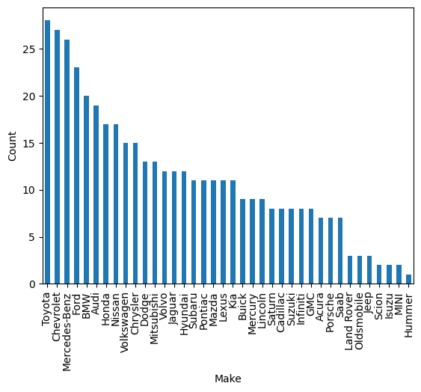
# Evaluate the 'Model' categorical variable.
Cars_df['Model'].describe()
count 428
unique 425
top G35 4dr
freq 2
Name: Model, dtype: object
# Evaluate the 'Type' categorical variable.
Cars_df['Type'].describe()
count 428
unique 6
top Sedan
freq 262
Name: Type, dtype: object
# Barchart for the 'Type' categorical variable.
Cars_df['Type'].value_counts().plot(kind='bar')
plt.ylabel('Count')
plt.show()
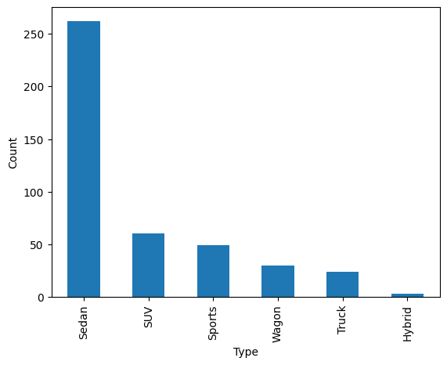
# Evaluate the 'Origin' categorical variable.
Cars_df['Origin'].describe()
count 428
unique 3
top Asia
freq 158
Name: Origin, dtype: object
# Barchart for the 'Origin' categorical variable.
Cars_df['Origin'].value_counts().plot(kind='bar')
plt.ylabel('Count')
plt.show()
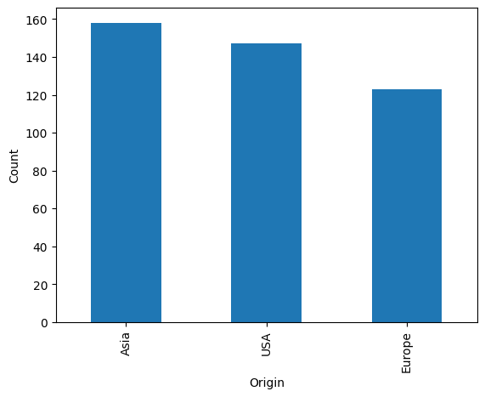
# Evaluate the 'DriveTrain' categorical variable.
Cars_df['DriveTrain'].describe()
count 428
unique 3
top Front
freq 226
Name: DriveTrain, dtype: object
# Barchart for the 'DriveTrain' categorical variable.
Cars_df['DriveTrain'].value_counts().plot(kind='bar')
plt.ylabel('Count')
plt.show()
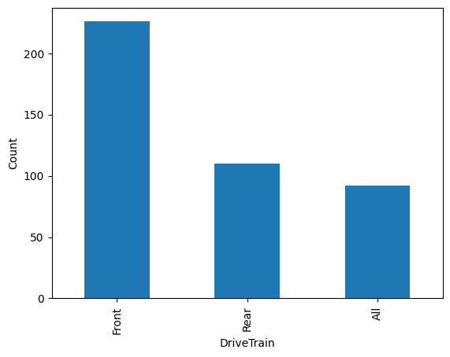
# Convert the 'MSRP' variable from an object to a float.
Cars_df['MSRP'] = Cars_df['MSRP'].replace('[$,]','',regex=True).astype(float)
# Convert the 'Invoice' variable from an object to a float.
Cars_df['Invoice'] = Cars_df['Invoice'].replace('[$,]','',regex=True).astype(float)

Cars_df.describe()
MSRP Invoice EngineSize Cylinders Horsepower
count 428.000000 428.000000 428.000000 426.000000 428.000000
mean 32774.855140 30014.700935 3.196729 5.807512 215.885514
std 19431.716674 17642.117750 1.108595 1.558443 71.836032
min 10280.000000 9875.000000 1.300000 3.000000 73.000000
25% 20334.250000 18866.000000 2.375000 4.000000 165.000000
50% 27635.000000 25294.500000 3.000000 6.000000 210.000000
75% 39205.000000 35710.250000 3.900000 6.000000 255.000000
max 192465.000000 173560.000000 8.300000 12.000000 500.000000
MPG_City MPG_Highway Weight Wheelbase Length
count 428.000000 428.000000 428.000000 428.000000 428.000000
mean 20.060748 26.843458 3577.953271 108.154206 186.362150
std 5.238218 5.741201 758.983215 8.311813 14.357991
min 10.000000 12.000000 1850.000000 89.000000 143.000000
25% 17.000000 24.000000 3104.000000 103.000000 178.000000
50% 19.000000 26.000000 3474.500000 107.000000 187.000000
75% 21.250000 29.000000 3977.750000 112.000000 194.000000
max 60.000000 66.000000 7190.000000 144.000000 238.000000
# Histogram for the 'MSRP' numerical variable.
plt.hist(Cars_df['MSRP'], bins = 20, alpha = 0.75, color = 'green', edgecolor = 'black')
plt.xlabel('MSRP')
plt.ylabel('Frequency')
plt.xlim(0, 200000)
mean_value = Cars_df['MSRP'].mean()
median_value = Cars_df['MSRP'].median()
std_value = Cars_df['MSRP'].std()
plt.axvline(mean_value, color='red', linewidth=2, label=f'Mean: {mean_value: .2f}')
plt.axvline(median_value, color='blue', linestyle='dashed', linewidth=1.5, label=f'Median: {median_value: .2f}')
plt.axvline(mean_value+std_value, color='red', linestyle='dashed', linewidth=1.5, label=f'1 SD')
plt.axvline(mean_value-std_value, color='red', linestyle='dashed', linewidth=1.5)
plt.axvline(mean_value+2*std_value, color='red', linestyle='dashed', linewidth=1, label=f'2 SD')
plt.axvline(mean_value-2*std_value, color='red', linestyle='dashed', linewidth=1)
plt.axvline(mean_value+3*std_value, color='red', linestyle='dashed', linewidth=0.5, label=f'3 SD')
plt.axvline(mean_value-3*std_value, color='red', linestyle='dashed', linewidth=0.5)
plt.show()
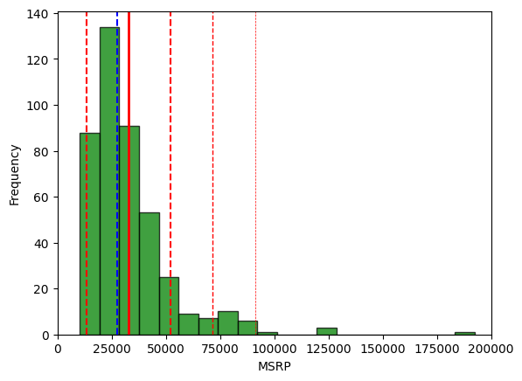
# Boxplot for the 'MSRP' numeric variable.
fig = plt.figure(figsize =(5, 7))
ax = fig.add_subplot(111)
# Creating axes instance
bp = ax.boxplot(Cars_df['MSRP'], patch_artist = True,
notch ='True')
for patch, color in zip(bp['boxes'], 'green'):
patch.set_facecolor('green')
# Changing color and linewidth of whiskers.
for whisker in bp['whiskers']:
whisker.set(color ='green',
linewidth = 1.5,
linestyle =":")
# Changing color and linewidth of caps.
for cap in bp['caps']:
cap.set(color ='black',
linewidth = 2)
# Changing color and linewidth of median.
for median in bp['medians']:
median.set(color ='blue',
linewidth = 3)
# Changing style of fliers.
for flier in bp['fliers']:
flier.set(marker ='D',
alpha = 0.5)
# Set axis labels.
ax.set_ylabel('MSRP')
ax.set_xticklabels('')
# Set axis limits.
ax.set_ylim(0,200000)
# Display the mean.
plt.axhline(mean_value, color='red', linewidth=1, linestyle='dashed', label=f'Mean: {mean_value: .2f}')
plt.show()
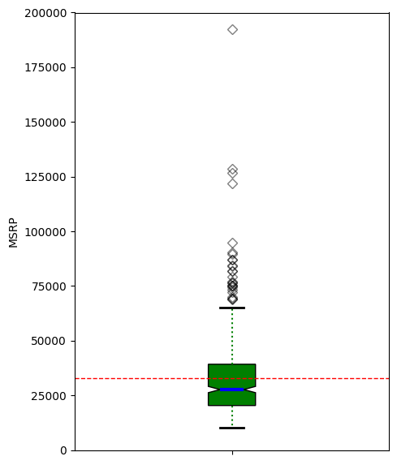
# 'MSRP' Anderson-Darling Normality Test
result = anderson(Cars_df['MSRP'])
print('Statistic: %.3f' % result.statistic)
p = 0
for i in range(len(result.critical_values)):
sl, cv = result.significance_level[i], result.critical_values[i]
if result.statistic < result.critical_values[i]:
print('%.3f: %.3f, data looks normal (fail to reject H0)' % (sl, cv))
else:
print('%.3f: %.3f, data does not look normal (reject H0)' % (sl, cv))
Statistic: 19.845
15.000: 0.571, data does not look normal (reject H0)
10.000: 0.650, data does not look normal (reject H0)
5.000: 0.780, data does not look normal (reject H0)
2.500: 0.910, data does not look normal (reject H0)
1.000: 1.082, data does not look normal (reject H0)
# 'MSRP' QQ plot
qqplot(Cars_df['MSRP'], line='s')
plt.show()
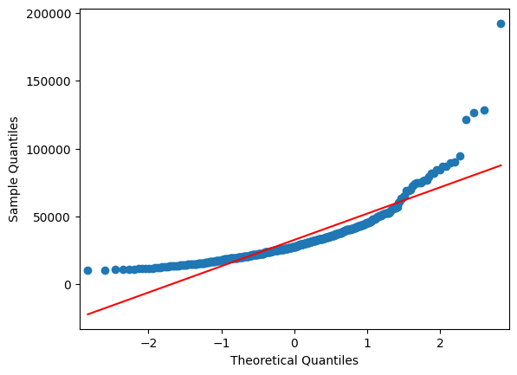
# Histogram for the 'Invoice' numerical variable.
plt.hist(Cars_df['Invoice'], bins = 20, alpha = 0.75, color = 'green', edgecolor = 'black')
plt.xlabel('Invoice')
plt.ylabel('Frequency')
plt.xlim(0, 200000)
mean_value = Cars_df['Invoice'].mean()
median_value = Cars_df['Invoice'].median()
std_value = Cars_df['Invoice'].std()
plt.axvline(mean_value, color='red', linewidth=2, label=f'Mean: {mean_value: .2f}')
plt.axvline(median_value, color='blue', linestyle='dashed', linewidth=1.5, label=f'Median: {median_value: .2f}')
plt.axvline(mean_value+std_value, color='red', linestyle='dashed', linewidth=1.5, label=f'1 SD')
plt.axvline(mean_value-std_value, color='red', linestyle='dashed', linewidth=1.5)
plt.axvline(mean_value+2*std_value, color='red', linestyle='dashed', linewidth=1, label=f'2 SD')
plt.axvline(mean_value-2*std_value, color='red', linestyle='dashed', linewidth=1)
plt.axvline(mean_value+3*std_value, color='red', linestyle='dashed', linewidth=0.5, label=f'3 SD')
plt.axvline(mean_value-3*std_value, color='red', linestyle='dashed', linewidth=0.5)
plt.show()
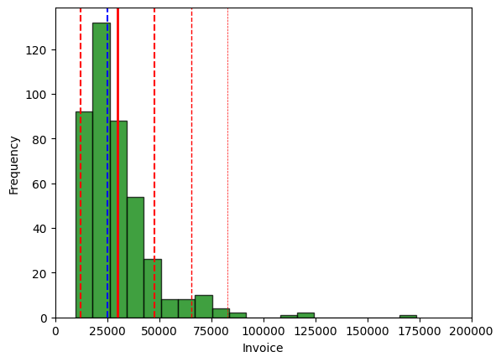
# Boxplot for the 'Invoice' numeric variable.
fig = plt.figure(figsize =(5, 7))
ax = fig.add_subplot(111)
# Creating axes instance
bp = ax.boxplot(Cars_df['Invoice'], patch_artist = True,
notch ='True')
for patch, color in zip(bp['boxes'], 'green'):
patch.set_facecolor('green')
# Changing color and linewidth of whiskers.
for whisker in bp['whiskers']:
whisker.set(color ='green',
linewidth = 1.5,
linestyle =":")
# Changing color and linewidth of caps.
for cap in bp['caps']:
cap.set(color ='black',
linewidth = 2)
# Changing color and linewidth of median.
for median in bp['medians']:
median.set(color ='blue',
linewidth = 3)
# Changing style of fliers.
for flier in bp['fliers']:
flier.set(marker ='D',
alpha = 0.5)
# Set axis labels.
ax.set_ylabel('Invoice')
ax.set_xticklabels('')
# Set axis limits.
ax.set_ylim(0,200000)
# Display the mean.
plt.axhline(mean_value, color='red', linewidth=1, linestyle='dashed', label=f'Mean: {mean_value: .2f}')
plt.show()
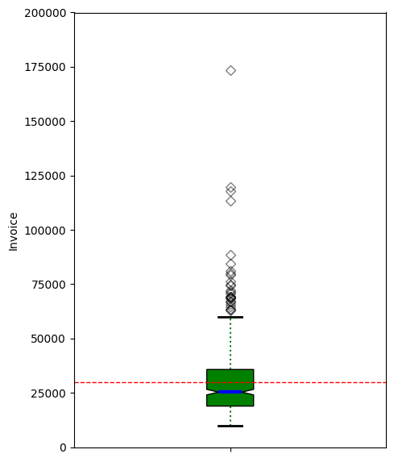
# 'Invoice' Anderson-Darling Normality Test
result = anderson(Cars_df['Invoice'])
print('Statistic: %.3f' % result.statistic)
p = 0
for i in range(len(result.critical_values)):
sl, cv = result.significance_level[i], result.critical_values[i]
if result.statistic < result.critical_values[i]:
print('%.3f: %.3f, data looks normal (fail to reject H0)' % (sl, cv))
else:
print('%.3f: %.3f, data does not look normal (reject H0)' % (sl, cv))
Statistic: 20.395
15.000: 0.571, data does not look normal (reject H0)
10.000: 0.650, data does not look normal (reject H0)
5.000: 0.780, data does not look normal (reject H0)
2.500: 0.910, data does not look normal (reject H0)
1.000: 1.082, data does not look normal (reject H0)
# 'Invoice' QQ plot
qqplot(Cars_df['Invoice'], line='s')
plt.show()
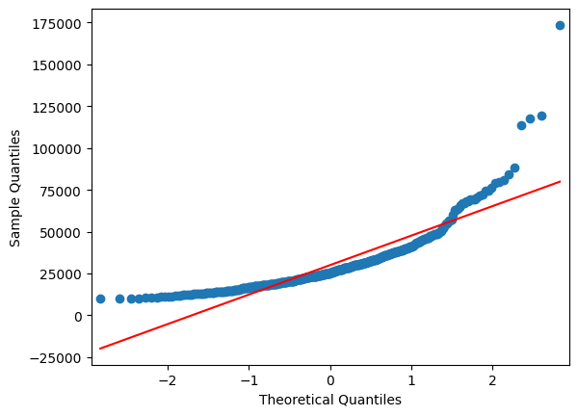
# Histogram for the 'EngineSize' numerical variable.
plt.hist(Cars_df['EngineSize'], bins = 20, alpha = 0.75, color = 'green', edgecolor = 'black')
plt.xlabel('Engine Size')
plt.ylabel('Frequency')
plt.xlim(0, 9)
mean_value = Cars_df['EngineSize'].mean()
median_value = Cars_df['EngineSize'].median()
std_value = Cars_df['EngineSize'].std()

plt.axvline(mean_value, color='red', linewidth=2, label=f'Mean: {mean_value: .2f}')
plt.axvline(median_value, color='blue', linestyle='dashed', linewidth=1.5, label=f'Median: {median_value: .2f}')
plt.axvline(mean_value+std_value, color='red', linestyle='dashed', linewidth=1.5, label=f'1 SD')
plt.axvline(mean_value-std_value, color='red', linestyle='dashed', linewidth=1.5)
plt.axvline(mean_value+2*std_value, color='red', linestyle='dashed', linewidth=1, label=f'2 SD')
plt.axvline(mean_value-2*std_value, color='red', linestyle='dashed', linewidth=1)
plt.axvline(mean_value+3*std_value, color='red', linestyle='dashed', linewidth=0.5, label=f'3 SD')
plt.axvline(mean_value-3*std_value, color='red', linestyle='dashed', linewidth=0.5)
plt.show()
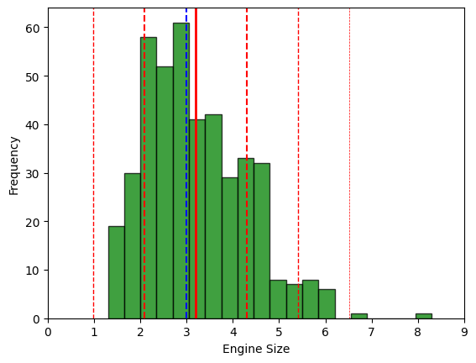
# Boxplot for the 'EngineSize' numeric variable.
fig = plt.figure(figsize =(5, 7))
ax = fig.add_subplot(111)
# Creating axes instance.
bp = ax.boxplot(Cars_df['EngineSize'], patch_artist = True,
notch ='True')
for patch, color in zip(bp['boxes'], 'green'):
patch.set_facecolor('green')
# Changing color and linewidth of whiskers.
for whisker in bp['whiskers']:
whisker.set(color ='green',
linewidth = 1.5,
linestyle =":")
# Changing color and linewidth of caps.
for cap in bp['caps']:
cap.set(color ='black',
linewidth = 2)
# Changing color and linewidth of median.
for median in bp['medians']:
median.set(color ='blue',
linewidth = 3)
# Changing style of fliers.
for flier in bp['fliers']:
flier.set(marker ='D',
alpha = 0.5)
# Set axis labels.
ax.set_ylabel('Engine Size')
ax.set_xticklabels('')
# Set axis limits.
ax.set_ylim(0,9)
# Display the mean.
plt.axhline(mean_value, color='red', linewidth=1, linestyle='dashed', label=f'Mean: {mean_value: .2f}')
plt.show()
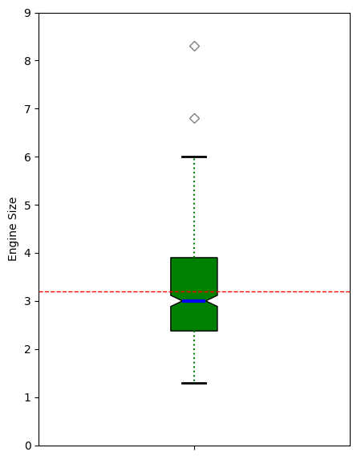
# 'EngineSize' Anderson-Darling Normality Test
result = anderson(Cars_df['EngineSize'])
print('Statistic: %.3f' % result.statistic)
p = 0
for i in range(len(result.critical_values)):
sl, cv = result.significance_level[i], result.critical_values[i]
if result.statistic < result.critical_values[i]:
print('%.3f: %.3f, data looks normal (fail to reject H0)' % (sl, cv))
else:
print('%.3f: %.3f, data does not look normal (reject H0)' % (sl, cv))
Statistic: 3.997
15.000: 0.571, data does not look normal (reject H0)
10.000: 0.650, data does not look normal (reject H0)
5.000: 0.780, data does not look normal (reject H0)
2.500: 0.910, data does not look normal (reject H0)
1.000: 1.082, data does not look normal (reject H0)
# 'EngineSize' QQ plot
qqplot(Cars_df['EngineSize'], line='s')
plt.show()
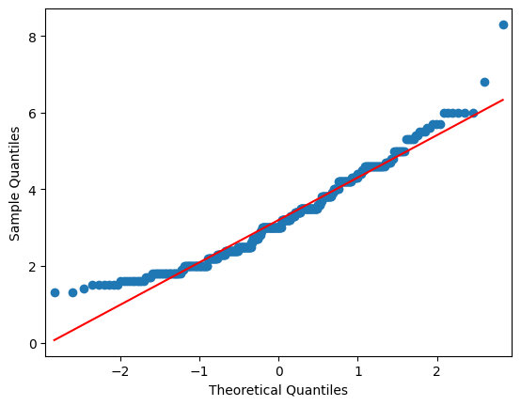

# Barchart for the 'Cylinders' numeric variable.
Cars_df['Cylinders'].value_counts().plot(kind='bar')
plt.ylabel('Count')
plt.show()
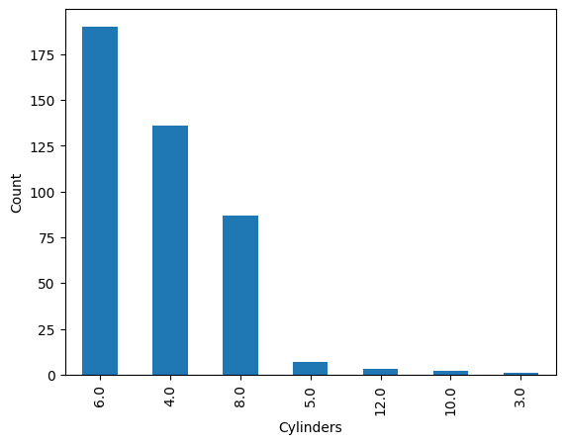
# Histogram for the 'Horsepower' numerical variable.
plt.hist(Cars_df['Horsepower'], bins = 20, alpha = 0.75, color = 'green', edgecolor = 'black')
plt.xlabel('Horsepower')
plt.ylabel('Frequency')
plt.xlim(0, 550)
mean_value = Cars_df['Horsepower'].mean()
median_value = Cars_df['Horsepower'].median()
std_value = Cars_df['Horsepower'].std()

plt.axvline(mean_value, color='red', linewidth=2, label=f'Mean: {mean_value: .2f}')
plt.axvline(median_value, color='blue', linestyle='dashed', linewidth=1.5, label=f'Median: {median_value: .2f}')
plt.axvline(mean_value+std_value, color='red', linestyle='dashed', linewidth=1.5, label=f'1 SD')
plt.axvline(mean_value-std_value, color='red', linestyle='dashed', linewidth=1.5)
plt.axvline(mean_value+2*std_value, color='red', linestyle='dashed', linewidth=1, label=f'2 SD')
plt.axvline(mean_value-2*std_value, color='red', linestyle='dashed', linewidth=1)
plt.axvline(mean_value+3*std_value, color='red', linestyle='dashed', linewidth=0.5, label=f'3 SD')
plt.axvline(mean_value-3*std_value, color='red', linestyle='dashed', linewidth=0.5)
plt.show()
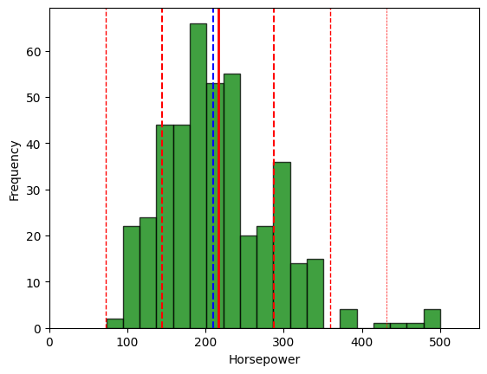
# Boxplot for the 'Horsepower' numeric variable.
fig = plt.figure(figsize =(5, 7))
ax = fig.add_subplot(111)
# Creating axes instance.
bp = ax.boxplot(Cars_df['Horsepower'], patch_artist = True,
notch ='True')
for patch, color in zip(bp['boxes'], 'green'):
patch.set_facecolor('green')
# Changing color and linewidth of whiskers.
for whisker in bp['whiskers']:
whisker.set(color ='green',
linewidth = 1.5,
linestyle =":")
# Changing color and linewidth of caps.
for cap in bp['caps']:
cap.set(color ='black',
linewidth = 2)
# Changing color and linewidth of median.
for median in bp['medians']:
median.set(color ='blue',
linewidth = 3)
# Changing style of fliers.
for flier in bp['fliers']:
flier.set(marker ='D',
alpha = 0.5)
# Set axis labels.
ax.set_ylabel('Horsepower')
ax.set_xticklabels('')
# Set axis limits.
ax.set_ylim(0,550)
# Display the mean.
plt.axhline(mean_value, color='red', linewidth=1, linestyle='dashed', label=f'Mean: {mean_value: .2f}')
plt.show()
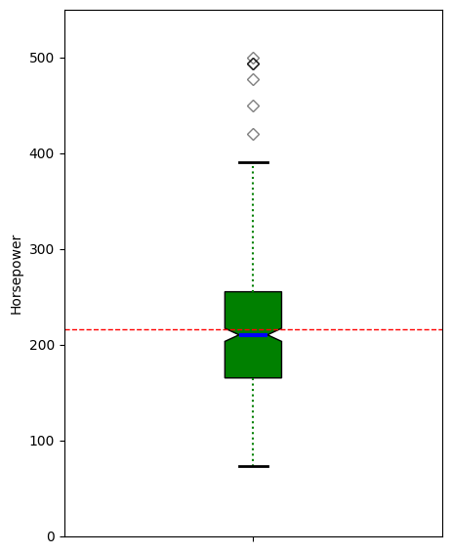
# 'Horsepower' Anderson-Darling Normality Test
result = anderson(Cars_df['Horsepower'])
print('Statistic: %.3f' % result.statistic)
p = 0
for i in range(len(result.critical_values)):
sl, cv = result.significance_level[i], result.critical_values[i]
if result.statistic < result.critical_values[i]:
print('%.3f: %.3f, data looks normal (fail to reject H0)' % (sl, cv))
else:
print('%.3f: %.3f, data does not look normal (reject H0)' % (sl, cv))
Statistic: 3.686
15.000: 0.571, data does not look normal (reject H0)
10.000: 0.650, data does not look normal (reject H0)
5.000: 0.780, data does not look normal (reject H0)
2.500: 0.910, data does not look normal (reject H0)
1.000: 1.082, data does not look normal (reject H0)
# 'Horsepower' QQ plot
qqplot(Cars_df['Horsepower'], line='s')
plt.show()
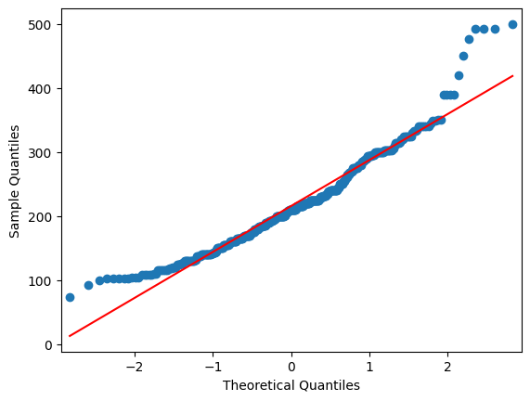
# Histogram for the 'MPG_City' numerical variable.
plt.hist(Cars_df['MPG_City'], bins = 20, alpha = 0.75, color = 'green', edgecolor = 'black')
plt.xlabel('MPG City')
plt.ylabel('Frequency')
plt.xlim(0, 65)
mean_value = Cars_df['MPG_City'].mean()
median_value = Cars_df['MPG_City'].median()
std_value = Cars_df['MPG_City'].std()

plt.axvline(mean_value, color='red', linewidth=2, label=f'Mean: {mean_value: .2f}')
plt.axvline(median_value, color='blue', linestyle='dashed', linewidth=1.5, label=f'Median: {median_value: .2f}')
plt.axvline(mean_value+std_value, color='red', linestyle='dashed', linewidth=1.5, label=f'1 SD')
plt.axvline(mean_value-std_value, color='red', linestyle='dashed', linewidth=1.5)
plt.axvline(mean_value+2*std_value, color='red', linestyle='dashed', linewidth=1, label=f'2 SD')
plt.axvline(mean_value-2*std_value, color='red', linestyle='dashed', linewidth=1)
plt.axvline(mean_value+3*std_value, color='red', linestyle='dashed', linewidth=0.5, label=f'3 SD')
plt.axvline(mean_value-3*std_value, color='red', linestyle='dashed', linewidth=0.5)
plt.show()
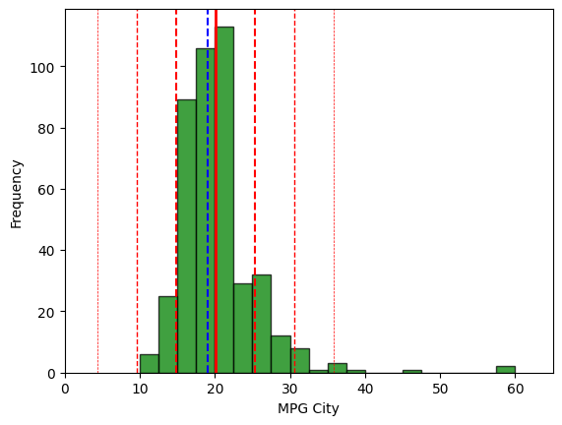
# Boxplot for the 'MPG_City' numeric variable.
fig = plt.figure(figsize =(5, 7))
ax = fig.add_subplot(111)
# Creating axes instance.
bp = ax.boxplot(Cars_df['MPG_City'], patch_artist = True,
notch ='True')
for patch, color in zip(bp['boxes'], 'green'):
patch.set_facecolor('green')
# Changing color and linewidth of whiskers.
for whisker in bp['whiskers']:
whisker.set(color ='green',
linewidth = 1.5,
linestyle =":")
# Changing color and linewidth of caps.
for cap in bp['caps']:
cap.set(color ='black',
linewidth = 2)
# Changing color and linewidth of median.
for median in bp['medians']:
median.set(color ='blue',
linewidth = 3)
# Changing style of fliers.
for flier in bp['fliers']:
flier.set(marker ='D',
alpha = 0.5)
# Set axis labels.
ax.set_ylabel('MPG City')
ax.set_xticklabels('')
# Set axis limits.
ax.set_ylim(0,65)
# Display the mean.
plt.axhline(mean_value, color='red', linewidth=1, linestyle='dashed', label=f'Mean: {mean_value: .2f}')
plt.show()
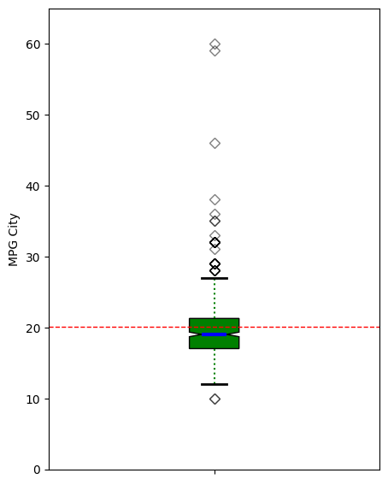
# 'MPG_City' Anderson-Darling Normality Test
result = anderson(Cars_df['MPG_City'])
print('Statistic: %.3f' % result.statistic)
p = 0
for i in range(len(result.critical_values)):
sl, cv = result.significance_level[i], result.critical_values[i]
if result.statistic < result.critical_values[i]:
print('%.3f: %.3f, data looks normal (fail to reject H0)' % (sl, cv))
else:
print('%.3f: %.3f, data does not look normal (reject H0)' % (sl, cv))
Statistic: 14.673
15.000: 0.571, data does not look normal (reject H0)
10.000: 0.650, data does not look normal (reject H0)
5.000: 0.780, data does not look normal (reject H0)
2.500: 0.910, data does not look normal (reject H0)
1.000: 1.082, data does not look normal (reject H0)
# 'MPG_City' QQ plot
qqplot(Cars_df['MPG_City'], line='s')
plt.show()
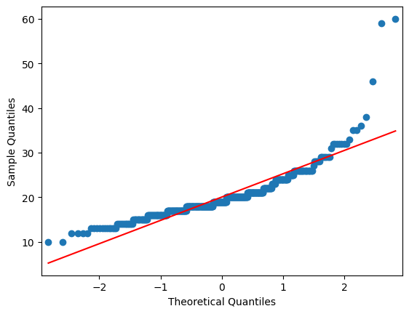
# Histogram for the 'MPG_Highway' numerical variable.
plt.hist(Cars_df['MPG_Highway'], bins = 20, alpha = 0.75, color = 'green', edgecolor = 'black')
plt.xlabel('MPG Highway')
plt.ylabel('Frequency')
plt.xlim(5, 70)
mean_value = Cars_df['MPG_Highway'].mean()
median_value = Cars_df['MPG_Highway'].median()
std_value = Cars_df['MPG_Highway'].std()

plt.axvline(mean_value, color='red', linewidth=2, label=f'Mean: {mean_value: .2f}')
plt.axvline(median_value, color='blue', linestyle='dashed', linewidth=1.5, label=f'Median: {median_value: .2f}')
plt.axvline(mean_value+std_value, color='red', linestyle='dashed', linewidth=1.5, label=f'1 SD')
plt.axvline(mean_value-std_value, color='red', linestyle='dashed', linewidth=1.5)
plt.axvline(mean_value+2*std_value, color='red', linestyle='dashed', linewidth=1, label=f'2 SD')
plt.axvline(mean_value-2*std_value, color='red', linestyle='dashed', linewidth=1)
plt.axvline(mean_value+3*std_value, color='red', linestyle='dashed', linewidth=0.5, label=f'3 SD')
plt.axvline(mean_value-3*std_value, color='red', linestyle='dashed', linewidth=0.5)
plt.show()
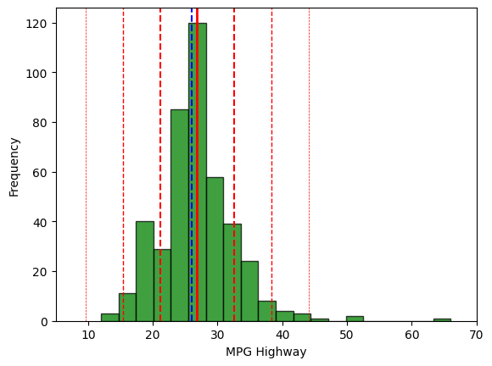
# Boxplot for the 'MPG_Highway' numeric variable.
fig = plt.figure(figsize =(5, 7))
ax = fig.add_subplot(111)
# Creating axes instance.
bp = ax.boxplot(Cars_df['MPG_Highway'], patch_artist = True,
notch ='True')
for patch, color in zip(bp['boxes'], 'green'):
patch.set_facecolor('green')
# Changing color and linewidth of whiskers.
for whisker in bp['whiskers']:
whisker.set(color ='green',
linewidth = 1.5,
linestyle =":")
# Changing color and linewidth of caps.
for cap in bp['caps']:
cap.set(color ='black',
linewidth = 2)
# Changing color and linewidth of median.
for median in bp['medians']:
median.set(color ='blue',
linewidth = 3)
# Changing style of fliers.
for flier in bp['fliers']:
flier.set(marker ='D',
alpha = 0.5)
# Set axis labels.
ax.set_ylabel('MPG Highway')
ax.set_xticklabels('')
# Set axis limits.
ax.set_ylim(5,70)
# Display the mean.
plt.axhline(mean_value, color='red', linewidth=1, linestyle='dashed', label=f'Mean: {mean_value: .2f}')
plt.show()
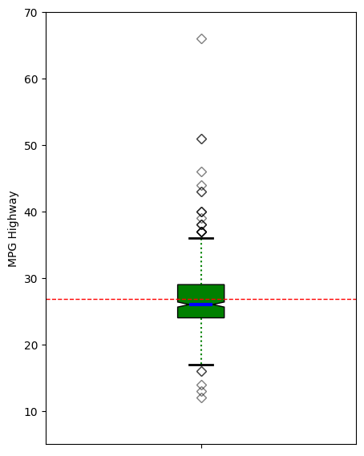
# 'MPG_Highway' Anderson-Darling Normality Test
result = anderson(Cars_df['MPG_Highway'])
print('Statistic: %.3f' % result.statistic)
p = 0
for i in range(len(result.critical_values)):
sl, cv = result.significance_level[i], result.critical_values[i]
if result.statistic < result.critical_values[i]:
print('%.3f: %.3f, data looks normal (fail to reject H0)' % (sl, cv))
else:
print('%.3f: %.3f, data does not look normal (reject H0)' % (sl, cv))
Statistic: 4.589
15.000: 0.571, data does not look normal (reject H0)
10.000: 0.650, data does not look normal (reject H0)
5.000: 0.780, data does not look normal (reject H0)
2.500: 0.910, data does not look normal (reject H0)
1.000: 1.082, data does not look normal (reject H0)
# 'MPG_Highway' QQ plot
qqplot(Cars_df['MPG_Highway'], line='s')
plt.show()
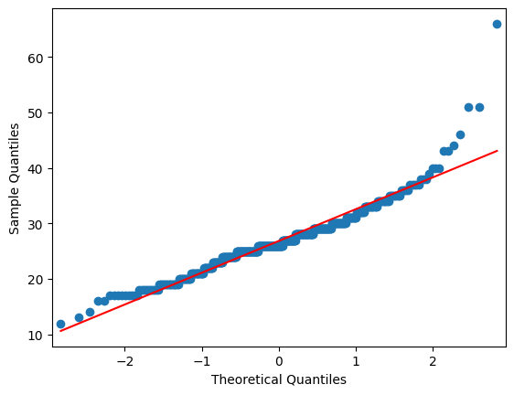
# Histogram for the 'Weight' numerical variable.
plt.hist(Cars_df['Weight'], bins = 20, alpha = 0.75, color = 'green', edgecolor = 'black')
plt.xlabel('Weight')
plt.ylabel('Frequency')
plt.xlim(1000, 8000)
mean_value = Cars_df['Weight'].mean()
median_value = Cars_df['Weight'].median()
std_value = Cars_df['Weight'].std()

plt.axvline(mean_value, color='red', linewidth=2, label=f'Mean: {mean_value: .2f}')
plt.axvline(median_value, color='blue', linestyle='dashed', linewidth=1.5, label=f'Median: {median_value: .2f}')
plt.axvline(mean_value+std_value, color='red', linestyle='dashed', linewidth=1.5, label=f'1 SD')
plt.axvline(mean_value-std_value, color='red', linestyle='dashed', linewidth=1.5)
plt.axvline(mean_value+2*std_value, color='red', linestyle='dashed', linewidth=1, label=f'2 SD')
plt.axvline(mean_value-2*std_value, color='red', linestyle='dashed', linewidth=1)
plt.axvline(mean_value+3*std_value, color='red', linestyle='dashed', linewidth=0.5, label=f'3 SD')
plt.axvline(mean_value-3*std_value, color='red', linestyle='dashed', linewidth=0.5)
plt.show()
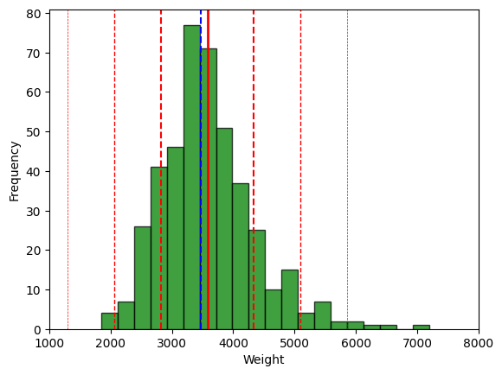
# Boxplot for the 'Weight' numeric variable.
fig = plt.figure(figsize =(5, 7))
ax = fig.add_subplot(111)
# Creating axes instance.
bp = ax.boxplot(Cars_df['Weight'], patch_artist = True,
notch ='True')
for patch, color in zip(bp['boxes'], 'green'):
patch.set_facecolor('green')
# Changing color and linewidth of whiskers.
for whisker in bp['whiskers']:
whisker.set(color ='green',
linewidth = 1.5,
linestyle =":")
# Changing color and linewidth of caps.
for cap in bp['caps']:
cap.set(color ='black',
linewidth = 2)
# Changing color and linewidth of median.
for median in bp['medians']:
median.set(color ='blue',
linewidth = 3)
# Changing style of fliers.
for flier in bp['fliers']:
flier.set(marker ='D',
alpha = 0.5)
# Set axis labels.
ax.set_ylabel('Weight')
ax.set_xticklabels('')
# Set axis limits.
ax.set_ylim(1000,8000)
# Display the mean.
plt.axhline(mean_value, color='red', linewidth=1, linestyle='dashed', label=f'Mean: {mean_value: .2f}')
plt.show()
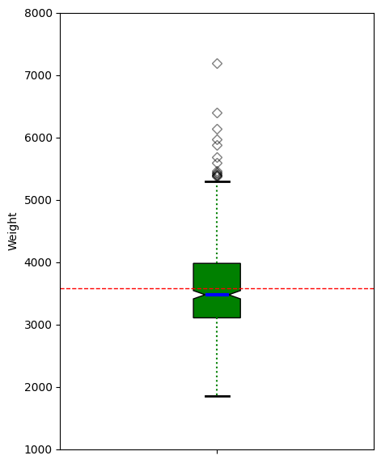
# 'Weight' Anderson-Darling Normality Test
result = anderson(Cars_df['Weight'])
print('Statistic: %.3f' % result.statistic)
p = 0
for i in range(len(result.critical_values)):
sl, cv = result.significance_level[i], result.critical_values[i]
if result.statistic < result.critical_values[i]:
print('%.3f: %.3f, data looks normal (fail to reject H0)' % (sl, cv))
else:
print('%.3f: %.3f, data does not look normal (reject H0)' % (sl, cv))
Statistic: 3.804
15.000: 0.571, data does not look normal (reject H0)
10.000: 0.650, data does not look normal (reject H0)
5.000: 0.780, data does not look normal (reject H0)
2.500: 0.910, data does not look normal (reject H0)
1.000: 1.082, data does not look normal (reject H0)
# 'Weight' QQ plot
qqplot(Cars_df['Weight'], line='s')
plt.show()
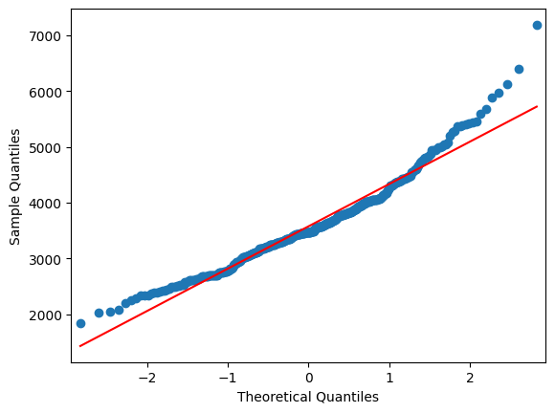
# Histogram for the 'Wheelbase' numerical variable.
plt.hist(Cars_df['Wheelbase'], bins = 20, alpha = 0.75, color = 'green', edgecolor = 'black')
plt.xlabel('Wheelbase')
plt.ylabel('Frequency')
plt.xlim(75, 150)
mean_value = Cars_df['Wheelbase'].mean()
median_value = Cars_df['Wheelbase'].median()
std_value = Cars_df['Wheelbase'].std()

plt.axvline(mean_value, color='red', linewidth=2, label=f'Mean: {mean_value: .2f}')
plt.axvline(median_value, color='blue', linestyle='dashed', linewidth=1.5, label=f'Median: {median_value: .2f}')
plt.axvline(mean_value+std_value, color='red', linestyle='dashed', linewidth=1.5, label=f'1 SD')
plt.axvline(mean_value-std_value, color='red', linestyle='dashed', linewidth=1.5)
plt.axvline(mean_value+2*std_value, color='red', linestyle='dashed', linewidth=1, label=f'2 SD')
plt.axvline(mean_value-2*std_value, color='red', linestyle='dashed', linewidth=1)
plt.axvline(mean_value+3*std_value, color='red', linestyle='dashed', linewidth=0.5, label=f'3 SD')
plt.axvline(mean_value-3*std_value, color='red', linestyle='dashed', linewidth=0.5)
plt.show()
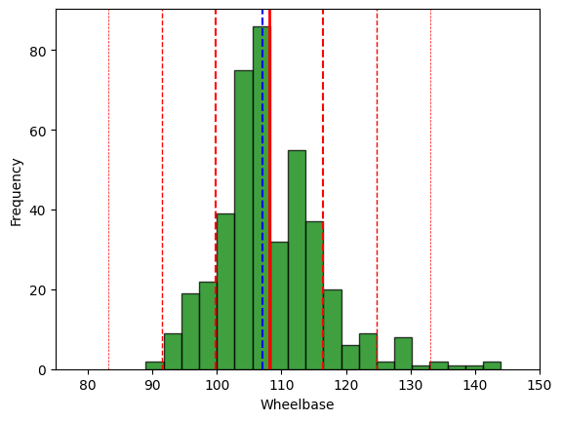
# Boxplot for the 'Wheelbase' numeric variable.
fig = plt.figure(figsize =(5, 7))
ax = fig.add_subplot(111)
# Creating axes instance.
bp = ax.boxplot(Cars_df['Wheelbase'], patch_artist = True,
notch ='True')
for patch, color in zip(bp['boxes'], 'green'):
patch.set_facecolor('green')
# Changing color and linewidth of whiskers.
for whisker in bp['whiskers']:
whisker.set(color ='green',
linewidth = 1.5,
linestyle =":")
# Changing color and linewidth of caps.
for cap in bp['caps']:
cap.set(color ='black',
linewidth = 2)
# Changing color and linewidth of median.
for median in bp['medians']:
median.set(color ='blue',
linewidth = 3)
# Changing style of fliers.
for flier in bp['fliers']:
flier.set(marker ='D',
alpha = 0.5)
# Set axis labels.
ax.set_ylabel('Wheelbase')
ax.set_xticklabels('')
# Set axis limits.
ax.set_ylim(75,150)
# Display the mean.
plt.axhline(mean_value, color='red', linewidth=1, linestyle='dashed', label=f'Mean: {mean_value: .2f}')
plt.show()
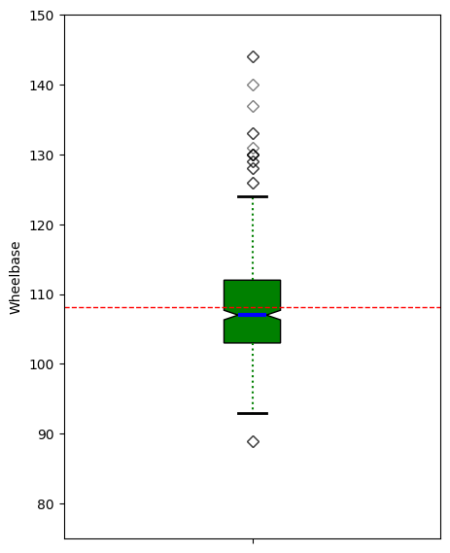
# 'Wheelbase' Anderson-Darling Normality Test
result = anderson(Cars_df['Wheelbase'])
print('Statistic: %.3f' % result.statistic)
p = 0
for i in range(len(result.critical_values)):
sl, cv = result.significance_level[i], result.critical_values[i]
if result.statistic < result.critical_values[i]:
print('%.3f: %.3f, data looks normal (fail to reject H0)' % (sl, cv))
else:
print('%.3f: %.3f, data does not look normal (reject H0)' % (sl, cv))
Statistic: 4.749
15.000: 0.571, data does not look normal (reject H0)
10.000: 0.650, data does not look normal (reject H0)
5.000: 0.780, data does not look normal (reject H0)
2.500: 0.910, data does not look normal (reject H0)
1.000: 1.082, data does not look normal (reject H0)
# 'Wheelbase' QQ plot
qqplot(Cars_df['Wheelbase'], line='s')
plt.show()
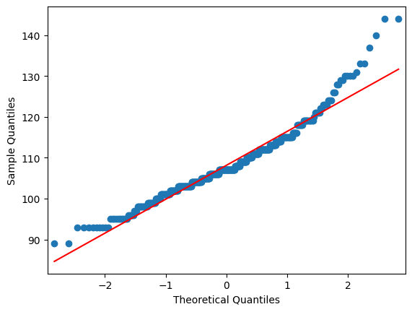
# Histogram for the 'Length' numerical variable.
plt.hist(Cars_df['Length'], bins = 20, alpha = 0.75, color = 'green', edgecolor = 'black')
plt.xlabel('Length')
plt.ylabel('Frequency')
plt.xlim(135, 245)
mean_value = Cars_df['Length'].mean()
median_value = Cars_df['Length'].median()
std_value = Cars_df['Length'].std()

plt.axvline(mean_value, color='red', linewidth=2, label=f'Mean: {mean_value: .2f}')
plt.axvline(median_value, color='blue', linestyle='dashed', linewidth=1.5, label=f'Median: {median_value: .2f}')
plt.axvline(mean_value+std_value, color='red', linestyle='dashed', linewidth=1.5, label=f'1 SD')
plt.axvline(mean_value-std_value, color='red', linestyle='dashed', linewidth=1.5)
plt.axvline(mean_value+2*std_value, color='red', linestyle='dashed', linewidth=1, label=f'2 SD')
plt.axvline(mean_value-2*std_value, color='red', linestyle='dashed', linewidth=1)
plt.axvline(mean_value+3*std_value, color='red', linestyle='dashed', linewidth=0.5, label=f'3 SD')
plt.axvline(mean_value-3*std_value, color='red', linestyle='dashed', linewidth=0.5)
plt.show()
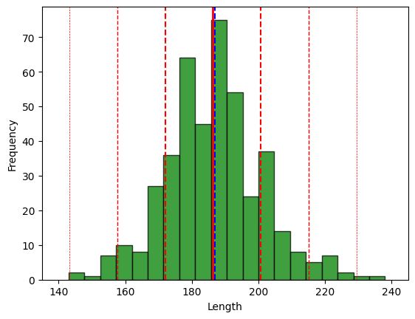
# Boxplot for the 'Length' numeric variable.
fig = plt.figure(figsize =(5, 7))
ax = fig.add_subplot(111)
# Creating axes instance.
bp = ax.boxplot(Cars_df['Length'], patch_artist = True,
notch ='True')
for patch, color in zip(bp['boxes'], 'green'):
patch.set_facecolor('green')
# Changing color and linewidth of whiskers.
for whisker in bp['whiskers']:
whisker.set(color ='green',
linewidth = 1.5,
linestyle =":")
# Changing color and linewidth of caps.
for cap in bp['caps']:
cap.set(color ='black',
linewidth = 2)
# Changing color and linewidth of median.
for median in bp['medians']:
median.set(color ='blue',
linewidth = 3)
# Changing style of fliers.
for flier in bp['fliers']:
flier.set(marker ='D',
alpha = 0.5)
# Set axis labels.
ax.set_ylabel('Length')
ax.set_xticklabels('')
# Set axis limits.
ax.set_ylim(135,245)
# Display the mean.
plt.axhline(mean_value, color='red', linewidth=1, linestyle='dashed', label=f'Mean: {mean_value: .2f}')
plt.show()
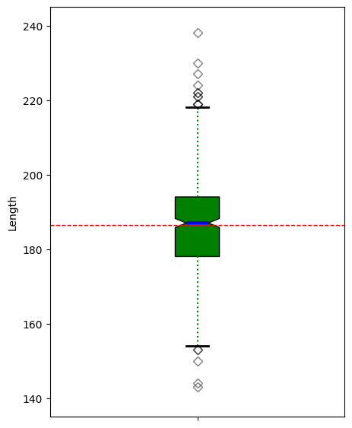
# 'Length' Anderson-Darling Normality Test
result = anderson(Cars_df['Length'])
print('Statistic: %.3f' % result.statistic)
p = 0
for i in range(len(result.critical_values)):
sl, cv = result.significance_level[i], result.critical_values[i]
if result.statistic < result.critical_values[i]:
print('%.3f: %.3f, data looks normal (fail to reject H0)' % (sl, cv))
else:
print('%.3f: %.3f, data does not look normal (reject H0)' % (sl, cv))
Statistic: 1.286
15.000: 0.571, data does not look normal (reject H0)
10.000: 0.650, data does not look normal (reject H0)
5.000: 0.780, data does not look normal (reject H0)
2.500: 0.910, data does not look normal (reject H0)
1.000: 1.082, data does not look normal (reject H0)
# 'Length' QQ plot
qqplot(Cars_df['Length'], line='s')
plt.show()
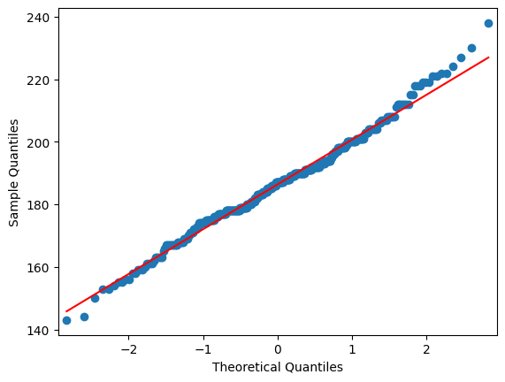
# Create data frame without object variables for correlation analysis.
Cars_corr=Cars_df[['MSRP','Invoice','EngineSize','Cylinders','Horsepower',
'MPG_City','MPG_Highway','Weight','Wheelbase','Length']]
# Generate heatmap for correlation matrix analysis.
corr = Cars_corr.corr()
fig, ax = plt.subplots()
sns.heatmap(corr, annot=True, fmt=".2f", xticklabels=corr.columns, yticklabels=corr.columns, vmin=-1, vmax=1, cmap="RdBu", ax=ax)
plt.show()
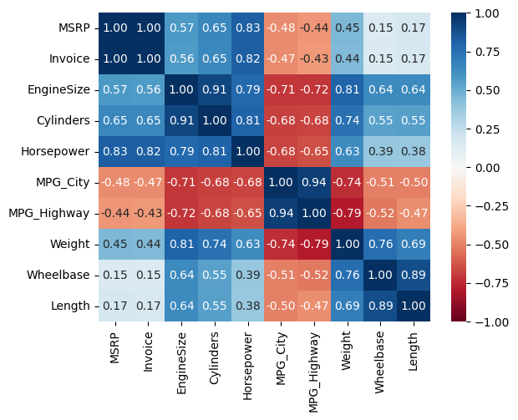
#Generate summary statistics for variables in correlation analysis.
summary_stats = Cars_corr.describe().map('{:,.3f}'.format)
summary_stats
MSRP Invoice EngineSize Cylinders Horsepower MPG_City
count 428.000 428.000 428.000 426.000 428.000 428.000
mean 32,774.855 30,014.701 3.197 5.808 215.886 20.061
std 19,431.717 17,642.118 1.109 1.558 71.836 5.238
min 10,280.000 9,875.000 1.300 3.000 73.000 10.000
25% 20,334.250 18,866.000 2.375 4.000 165.000 17.000
50% 27,635.000 25,294.500 3.000 6.000 210.000 19.000
75% 39,205.000 35,710.250 3.900 6.000 255.000 21.250
max 192,465.000 173,560.000 8.300 12.000 500.000 60.000
MPG_Highway Weight Wheelbase Length
count 428.000 428.000 428.000 428.000
mean 26.843 3,577.953 108.154 186.362
std 5.741 758.983 8.312 14.358
min 12.000 1,850.000 89.000 143.000
25% 24.000 3,104.000 103.000 178.000
50% 26.000 3,474.500 107.000 187.000
75% 29.000 3,977.750 112.000 194.000
max 66.000 7,190.000 144.000 238.000
Assignment Questions
- Generate a scatter plot matrix of the following continuous variables: MSRP, Invoice, Horsepower, MPG Highway, and MPG City. Briefly explain the relationships that you see among the following variables. (20 points)

# Create data frame for assignment.
Cars_Q1=Cars_df[['MSRP','Invoice', 'Horsepower', 'MPG_City','MPG_Highway']]
# View some initial records.
Cars_Q1.head()
MSRP Invoice Horsepower MPG_City MPG_Highway
0 36945.0 33337.0 265 17 23
1 23820.0 21761.0 200 24 31
2 26990.0 24647.0 200 22 29
3 33195.0 30299.0 270 20 28
4 43755.0 39014.0 225 18 24
# Generate requested scatter plot matrix.
scatter_matrix(Cars_Q1, diagonal="kde")
plt.show()
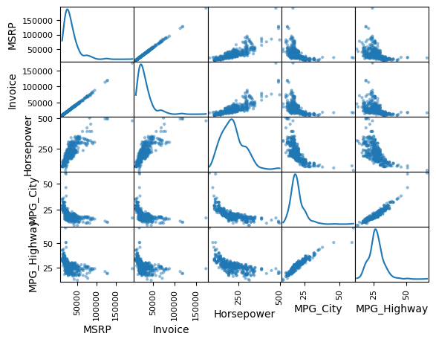
Answer for 1: There is a clear positive linear relationship between MSRP and Invoice. There is a notable positive linear relationship between MPG_City and MPG_Highway.
There is an approximate positive linear relationship between Horsepower and MSRP/Invoice. There is an approximate linear relationship between Horsepower and the negative of MPG_City and MPG_Highway.
- Use t-tests to accept or reject the statements listed below. State conclusions using the terminology of hypothesis testing: (40 pts)

o There is no difference in mileage between 'Front' drive and All-wheel drive.
o There is no difference in engine size between vehicles from the USA versus vehicles from Asia.
o There is no difference in the cost (MSRP or Invoice) between Wagon and Sedan vehicles.
o There is no difference in cost (MSRP or Invoice) between vehicles from the USA versus vehicles from Europe.

# 2.1 Regarding there is no difference in mileage between 'Front' and 'All' wheel drive.
# Barchart for the 'DriveTrain' by mean 'MPG_Highway'.
dfg = Cars_df.groupby(['DriveTrain'])['MPG_Highway'].mean()
dfg.plot(kind='bar', title='Mean MPG Highway by Drivetrain', ylabel='Mean MPG Highway', xlabel='Drivetrain', figsize=(6,5))
plt.show()
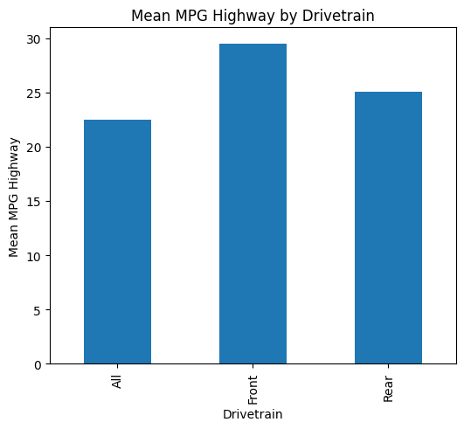

# Running a Two-Tailed Two-Sample T-Test in Python
# Define two independent samples.
class1_scores = Cars_df.groupby("DriveTrain").get_group("All")['MPG_Highway'].tolist()
class2_scores = Cars_df.groupby("DriveTrain").get_group("Front")['MPG_Highway'].tolist()
# Perform two-sample t-test
t_statistic, p_value = ttest_ind(class1_scores, class2_scores)
# Output the results
print(f"t-statistic: {t_statistic:0,.3f}")
print(f"P-value: {p_value:0,.3f}")
t-statistic: -10.450
P-value: 0.000
Answer for 2.1: Because the above p-value is less than the defined alpha of 0.05 (rejecting H0 the null hypothesis), and the t-statistic is sufficiently negative, we can say the mean highway MPG for front wheel drive (class 2) is higher with statistical significance than all wheel drive (class 1).
# 2.2 Regarding there is no difference in engine size between vehicles from the USA versus vehicles from Asia.
# Barchart for the 'Origin' by mean 'EngineSize'.
dfg = Cars_df.groupby(['Origin'])['EngineSize'].mean()
dfg.plot(kind='bar', title='Mean Engine Size by Origin', ylabel='Mean Engine Size', xlabel='Origin', figsize=(6,5))
plt.show()
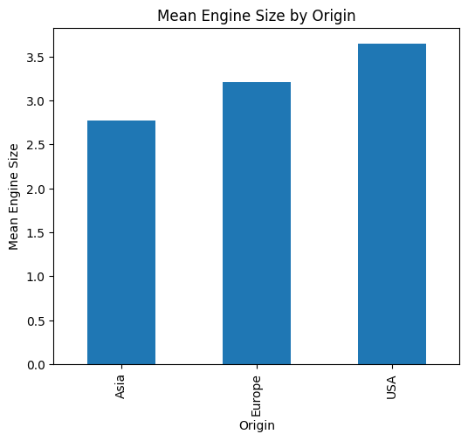
# Running a Two-Tailed Two-Sample T-Test in Python
# Define two independent samples.
class1_scores = Cars_df.groupby("Origin").get_group("Asia")['EngineSize'].tolist()
class2_scores = Cars_df.groupby("Origin").get_group("USA")['EngineSize'].tolist()
# Perform two-sample t-test
t_statistic, p_value = ttest_ind(class1_scores, class2_scores)
# Output the results
print(f"t-statistic: {t_statistic:0,.3f}")
print(f"P-value: {p_value:0,.3f}")
t-statistic: -7.199
P-value: 0.000
Answer for 2.2: Because the above p-value is less than the defined alpha 0f 0.05 (rejecting H0 the null hypothesis), and the t-statistic is sufficiently negative, we can say the mean engine size for USA made cars (class 2) is larger with statistical significance than Asia made cars (class 1).
# 2.3 Regarding there is no difference in the cost (MSRP or Invoice) between Wagon and Sedan vehicles.
# Multiple Barchart for the 'Type' by the mean 'MSRP' and 'Invoice'.
w = 0.4
x = ["Hybrid", "SUV", "Sedan", "Sports", "Truck", "Wagon"]
bar1 = np.arange(len(x))
bar2 = [i+w for i in bar1]
dfg1 = Cars_df.groupby(['Type']) ['MSRP'].mean()
dfg2 = Cars_df.groupby(['Type']) ['Invoice'].mean()
plt.bar(bar1, dfg1, w, color='blue', label="MSRP")
plt.bar(bar2, dfg2, w, color='red', label="Invoice")
plt.xlabel("Type")
plt.ylabel("Mean Price")
plt.title("Mean Price by Type")
plt.xticks(bar1+w/2,x)
plt.legend()
plt.show()
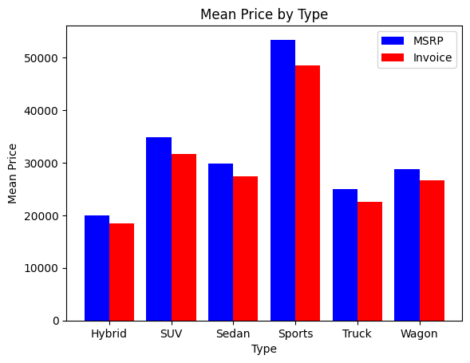
# Running a Two-Tailed Two-Sample T-Test in Python
# Define two independent samples.
class1_scores = Cars_df.groupby("Type").get_group("Sedan")['MSRP'].tolist()
class2_scores = Cars_df.groupby("Type").get_group("Wagon")['MSRP'].tolist()
# Perform two-sample t-test
t_statistic, p_value = ttest_ind(class1_scores, class2_scores)
# Output the results
print(f"t-statistic: {t_statistic:0,.3f}")
print(f"P-value: {p_value:0,.3f}")
t-statistic: 0.317
P-value: 0.751
Answer for 2.3: Because the above p-value is greater than the defined alpha of 0.05 (accepting H0 the null hypothesis), and the absolute value of the t-statistic is small, we can say the difference of mean MSRP for sedans (class 1) and wagons (class 2) are not statistically significant.
# 2.4 Regarding there is no difference in cost (MSRP or Invoice) between vehicles from the USA versus vehicles from Europe.
# Multiple Barchart for the 'Origin' by the mean 'MSRP' and 'Invoice'.
w = 0.4
x = ["Asia", "Europe", "USA"]
bar1 = np.arange(len(x))
bar2 = [i+w for i in bar1]
dfg1 = Cars_df.groupby(['Origin']) ['MSRP'].mean()
dfg2 = Cars_df.groupby(['Origin']) ['Invoice'].mean()
plt.bar(bar1, dfg1, w, color='blue', label="MSRP")
plt.bar(bar2, dfg2, w, color='red', label="Invoice")
plt.xlabel("Origin")
plt.ylabel("Mean Price")
plt.title("Mean Price by Origin")
plt.xticks(bar1+w/2,x)
plt.legend()
plt.show()
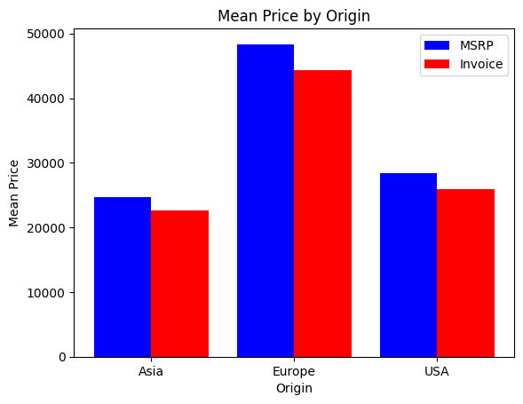

# Running a Two-Tailed Two-Sample T-Test in Python
# Define two independent samples.
class1_scores = Cars_df.groupby("Origin").get_group("Europe")['MSRP'].tolist()
class2_scores = Cars_df.groupby("Origin").get_group("USA")['MSRP'].tolist()
# Perform two-sample t-test.
t_statistic, p_value = ttest_ind(class1_scores, class2_scores)
# Output the results.
print(f"t-statistic: {t_statistic:0,.3f}")
print(f"P-value: {p_value:0,.3f}")
t-statistic: 8.537
P-value: 0.000
Answer for 2.4: Because the above p-value is less than the defined alpha 0f 0.05 (rejecting H0 the null hypothesis), and the t-statistic is sufficiently positive,
we can say the mean MSRP for Europe made cars (class 1) is higher with statistical significance than USA made cars (class 2).
- Provide estimates and standard errors for: (40 pts)

o Mean MPG (City) for all Vehicles
o Mean Horsepower for all Vehicles
o MPG (Highway) variance for vehicles in Asia
o MSRP variance for vehicles from the USA

# 3.1 Mean MPG (City) for all Vehicles
mean = Cars_df['MPG_City'].mean()
std = Cars_df['MPG_City'].std()
# Output the results.
print(f"*Mean: {mean:0,.2f}")
print(f"Standard Deviation: {std:0,.2f}")
*Mean: 20.06
Standard Deviation: 5.24

# 3.2 Mean Horsepower for all Vehicles
mean = Cars_df['Horsepower'].mean()
std = Cars_df['Horsepower'].std()
# Output the results.
print(f"*Mean: {mean:0,.2f}")
print(f"Standard Deviation: {std:0,.2f}")
*Mean: 215.89
Standard Deviation: 71.84
# 3.3 MPG (Highway) variance for vehicles in Asia
mean = Cars_df.groupby("Origin").get_group("Asia")['MPG_Highway'].mean()
std = Cars_df.groupby("Origin").get_group("Asia")['MPG_Highway'].std()
var = Cars_df.groupby("Origin").get_group("Asia")['MPG_Highway'].var()
# Output the results.
print(f"Mean: {mean:0,.2f}")
print(f"Standard Deviation: {std:0,.2f}")
print(f"*Variance: {var:0,.2f}")
Mean: 28.27
Standard Deviation: 6.77
*Variance: 45.84
# 3.4 MSRP variance for vehicles from the USA
mean = Cars_df.groupby("Origin").get_group("USA")['MSRP'].mean()
std = Cars_df.groupby("Origin").get_group("USA")['MSRP'].std()
var = Cars_df.groupby("Origin").get_group("USA")['MSRP'].var()
# Output the results.
print(f"Mean: {mean:0,.2f}")
print(f"Standard Deviation: {std:0,.2f}")
print(f"*Variance: {var:0,.2f}")
Mean: 28,377.44
Standard Deviation: 11,711.98
*Variance: 137,170,534.22
- Apply regression analysis to predict the gas mileage using two models: (50 pts)

o A simple model using one continuous variable (input) of your choice.
o A multiple regression model using three continuous variables of your choosing.
Explain the tabular and graphical output that is produced.

# Calculate the Total Sum of Squares (SST) for an empty model for MPG_Highway.
Y = Cars_df['MPG_Highway'].tolist()
Y_mean = np.mean(Y)
sst = np.sum((Y - Y_mean) ** 2)
print(f"SST = {sst:0,.3f}")
SST = 14,074.512
# 4.1 A simple model using one continuous variable (input) of your choice.
# Create requested simple model and scatterplot. Used MPG_Highway the outcome variable and Weight as the explanatory variable.
Cars_df.plot("Weight", "MPG_Highway", kind="scatter")
lm = smf.ols("MPG_Highway ~ Weight", data=Cars_df).fit()
xmin = Cars_df.Weight.min()
xmax = Cars_df.Weight.max()
X = np.linspace(xmin, xmax, 100)
# params[0] is the intercept (beta₀) & params[1] is the slope (beta₁)
Y = lm.params[0] + lm.params[1] * X
plt.plot(X, Y, color="darkred")
plt.show()

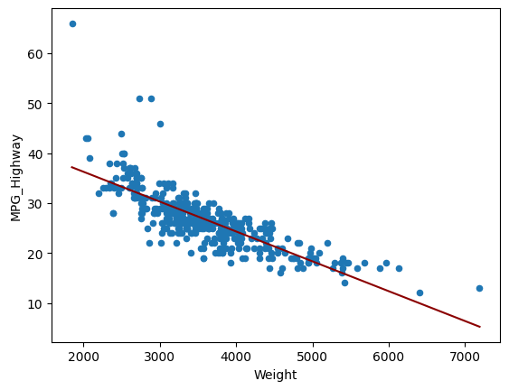
# Generate OLS Regression results for the simple model.
print(lm.summary())
print('\n')
# Residual Sum of Squares
print(f"RSS = {lm.ssr:0,.3f}")
# Sum of Squares Error
print(f"SSE = {sst-lm.ssr:0,.3f}")
OLS Regression Results
=============================================================================
Dep. Variable: MPG_Highway R-squared: 0.626
Model: OLS Adj. R-squared: 0.625
Method: Least Squares F-statistic: 712.0
Date: Sun, 09 Feb 2025 Prob (F-statistic): 6.21e-93
Time: 12:05:51 Log-Likelihood: -1144.5
No. Observations: 428 AIC: 2293.
Df Residuals: 426 BIC: 2301.
Df Model: 1
Covariance Type: nonrobust
=============================================================================
coef std err t P>|t| [0.025 0.975]
-----------------------------------------------------------------------------
Intercept 48.2515 0.820 58.836 0.000 46.640 49.863
Weight -0.0060 0.000 -26.684 0.000 -0.006 -0.006
=============================================================================
Omnibus: 250.719 Durbin-Watson: 1.394
Prob(Omnibus): 0.000 Jarque-Bera (JB): 4148.253
Skew: 2.148 Prob(JB): 0.00
Kurtosis: 17.634 Cond. No. 1.76e+04
=============================================================================
Notes:
[1] Standard Errors assume that the covariance matrix of the errors is correctly specified.
[2] The condition number is large, 1.76e+04. This might indicate that there are strong multicollinearity or other numerical problems.
RSS = 5,268.591
SSE = 8,805.921
4.1 Explain the tabular and graphical output that is produced.
Of all of the numeric variables, excluding MPG_City, Weight had the highest absolute correlation (0.79) with MPG_Highway, so it made sense to choose it for the explanatory variable in the simple model. In addition, neither variable passed normality tests, but MPG_Highway and Weight had a similarly right skewed distribution. Other than about five high 45-65 MPG_Highway values in the 2000-3000 Weight value range probably adding to the downward tilt in the regression line, the fitted regression line in the graphical output seems to reasonably traverse through the data.
The R-squared value of 0.626 indicates that 62.6% of the variation in the predicted MPG_Highway values can be explained by Weight in this simple model. The Y intercept, beta0, equals 48.2515 mpg at 0 lbs weight, and the regression line slope, beta1, equals -0.006 mpg per 1 lbs of weight. The F-statistic of 712.0 easily exceeds any reasonable threshold. The p-value is nearly zero and safely under the 0.05 alpha standard (rejecting H0 the null hypothesis), indicating clearly that the relationship between MPG_Highway and Weight is statistically significant.
# 4.2 A multiple regression model using three continuous variables of your choosing.
# Create preliminary a scatterplot with MPG_Highway to understand relationwhip of additional variables.
# Use MPG_Highway the outcome variable and Horsepower as the explanatory variable.
Cars_df.plot("Horsepower", "MPG_Highway", kind="scatter")
lm = smf.ols("MPG_Highway ~ Horsepower", data=Cars_df).fit()
xmin = Cars_df.Horsepower.min()
xmax = Cars_df.Horsepower.max()
X = np.linspace(xmin, xmax, 100)
# params[0] is the intercept (beta₀) & params[1] is the slope (beta₁)
Y = lm.params[0] + lm.params[1] * X
plt.plot(X, Y, color="darkgreen")
plt.show()
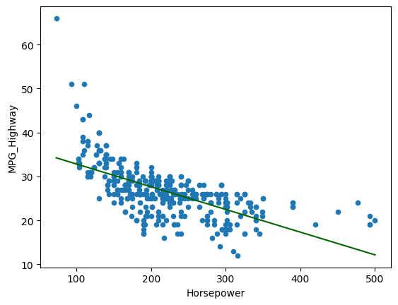
# Generate 3D plot of two significant explanatory variables and the outcome variable.
fig = plt.figure(figsize=(12,12))
ax = plt.axes(projection="3d")
x = Cars_df['Weight'].tolist()
y = Cars_df['Horsepower'].tolist()
z = Cars_df['MPG_Highway'].tolist()
my_cmap = plt.cm.magma
norm = mpl.colors.Normalize(vmin=10, vmax=60)
sctt = ax.scatter3D(x, y, z, c=z, alpha = 1, cmap=plt.cm.magma, marker = 'd')
ax.set_title('MPG Highway by Weight & Horsepower - 3D Scatterplot', fontweight='bold', fontsize=16)
ax.set_xlabel('Weight', fontweight='bold')
ax.set_ylabel("Horsepower", fontweight='bold')
ax.set_zlabel("MPG Highway", fontweight='bold')
ax.set_box_aspect(aspect = (1,1,1))
ax.view_init(elev=15, azim=45)
fig.colorbar(mpl.cm.ScalarMappable(norm = norm, cmap = my_cmap), ax = ax, shrink = 0.5, aspect = 5)
plt.show()
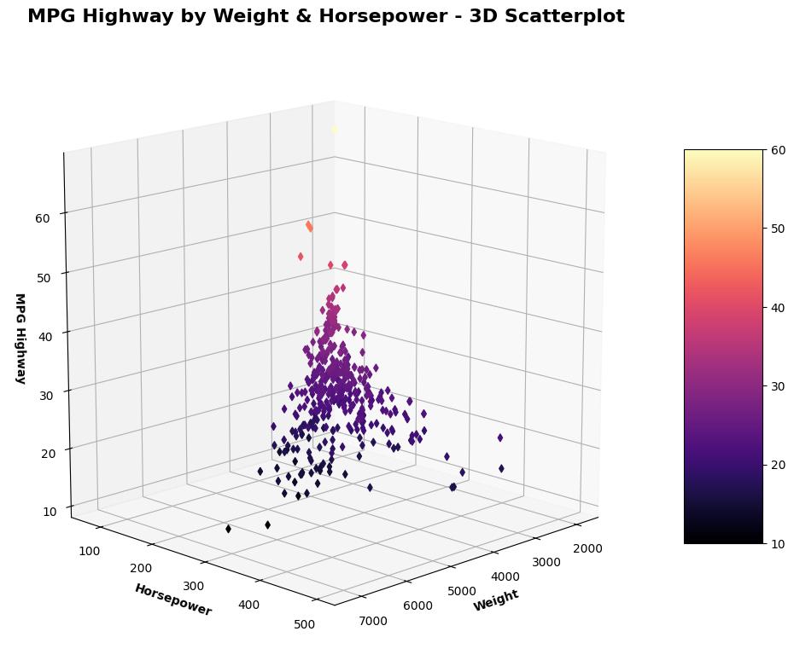
# Use MPG_Highway the outcome variable and Length as the explanatory variable.
Cars_df.plot("Length", "MPG_Highway", kind="scatter")
lm = smf.ols("MPG_Highway ~ Length", data=Cars_df).fit()
xmin = Cars_df.Length.min()
xmax = Cars_df.Length.max()
X = np.linspace(xmin, xmax, 100)
# params[0] is the intercept (beta₀) & params[1] is the slope (beta₁)
Y = lm.params[0] + lm.params[1] * X
plt.plot(X, Y, color="darkgreen")
plt.show()
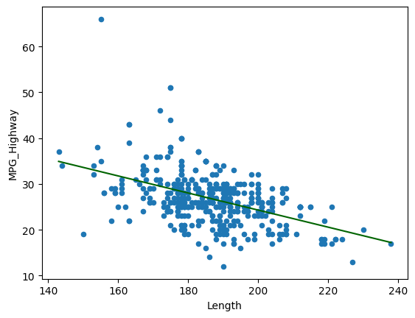
# Generate an initial multiple linear regression model using determined variables.
lm = smf.ols(formula='MPG_Highway ~ Weight + Horsepower + Length', data=Cars_df).fit()
print(lm.params)
Intercept 41.141582
Weight -0.005532
Horsepower -0.018764
Length 0.051214
dtype: float64
# Generate OLS Regression results for the initial multiple linear regression model.
print(lm.summary())
print('\n', '='*20, '\n')
# Residual Sum of Squares
print(f"RSS = {lm.ssr:0,.3f}")
# Sum of Squares Error
print(f"SSE = {sst-lm.ssr:0,.3f}")
OLS Regression Results
=============================================================================
Dep. Variable: MPG_Highway R-squared: 0.671
Model: OLS Adj. R-squared: 0.668
Method: Least Squares F-statistic: 287.8
Date: Sun, 09 Feb 2025 Prob (F-statistic): 7.34e-102
Time: 12:13:37 Log-Likelihood: -1117.1
No. Observations: 428 AIC: 2242.
Df Residuals: 424 BIC: 2258.
Df Model: 3
Covariance Type: nonrobust
=============================================================================
coef std err t P>|t| [0.025 0.975]
-----------------------------------------------------------------------------
Intercept 41.1416 2.294 17.933 0.000 36.632 45.651
Weight -0.0055 0.000 -15.870 0.000 -0.006 -0.005
Horsepower -0.0188 0.003 -6.507 0.000 -0.024 -0.013
Length 0.0512 0.015 3.311 0.001 0.021 0.082
=============================================================================
Omnibus: 272.214 Durbin-Watson: 1.353
Prob(Omnibus): 0.000 Jarque-Bera (JB): 5672.624
Skew: 2.327 Prob(JB): 0.00
Kurtosis: 20.217 Cond. No. 5.27e+04
=============================================================================
Notes:
[1] Standard Errors assume that the covariance matrix of the errors is correctly specified.
[2] The condition number is large, 5.27e+04. This might indicate that there are strong multicollinearity or other numerical problems.
====================
RSS = 4,635.039
SSE = 9,439.472
4.2 Explain the tabular and graphical output that is produced.
The decision to use the Weight variable as one of the required explanatory variables for the multiple linear regression model was an easy one after seeing the results of its performance in the simple model for estimating MPG_Highway. Of the remaining numeric variables (excluding MPG_City, MSRP, and Invoice, due to their lack of causality), Horsepower had the lowest correlation (0.63) with Weight, and had an absolute correlation of 0.65 with MPG_Highway, so it made the sense to choose it for the second explanatory variable in the multiple linear regression model. A scatter plot was developed to better visualize its relationship with the outcome variable MPG_Highway, it shared some similarities with the scatterplot for Weight and MPG_Highway. Out of curiosity, I put together a 3D scatter plot using all three variables with colormapping focused on MPG_Highway.
In addition, Horsepower failed normality tests, but shared a similarly right skewed distribution with MPG_Highway and Weight. All three variables had an Anderson- Darling statistic less than 5, but had a few notable outliers at the upper end of their distributions. For the third explanatory variable needed, Length was chosen. Length had the second lowest correlation (0.69) with Weight, had the lowest correlation (0.38) with Horsepower, but only had an absolute correlation of 0.47 with MPG_Highway. Length failed the A-D normality test probably because of outliers clearly illustrated in its generated box plot, but had the best A-D statistic of 1.286 of all of the numeric variables and the best looking QQ plot. A scatter plot was developed to better visualize its relationship with the outcome variable MPG_Highway, and it shared general similarities with the scatterplot for Horsepower and MPG_Highway.
After having determined the three required variables (Weight, Horsepower, Length), a OLS regression model was run with MPG_Highway as the outcome variable. The R-squared value of 0.671 indicates that 67.1% of the variation in the predicted MPG_Highway values can be attributed to this multiple linear regression model. The Y intercept, beta0, equals 41.1415 mpg at 0 lbs weight. Weight, beta1, equals -0.0055 mpg per 1 lbs of weight, Horsepower, beta2, equals -0.0188 mpg per 1 lbs of weight, and Length, beta3, equals 0.0512 mpg per 1 lbs of weight. The F-statistic of 287.8 comfortably exceeds any reasonable threshold. The p-value is nearly zero and safely under the 0.05 alpha standard (rejecting H0 the null hypothesis), indicating clearly that the relationship between MPG_Highway and the explanatory variables are statistically significant.
Experimented with other combinations of numeric variables, but my initial choice performed best. With MPG_Highway having a SST of 14,714.512, the simple model using the Weight variable reduced it 8,805.921 to a SSR of 5,268.591, which amounts to an approximate 64.2% reduction. The multiple linear regression model usiing Weight, Horsepower, and Length variables reduced it 9,439.472 to a SSR of 4,635.039, which amounts to an approximate 68.5% reduction. Even though the explanatory values did not pass normality tests for the most part, I did not endeavor to explore any transformations. If the use MSRP and/or Invoice variable was appropriate as an explanatory variable, I would have definitely looked into performing a logrithmic transformation for them.
Though the Length variable was statistically significant, it only improved the MLR model marginally. Think binary conversions of the values of the categorical variable Type, and possibly Drivetrain, could have improved the MLR model, increasing the r-square and decreasing the SSR. Although, we were only limited to using three variables, and Type would essentailly create six and Drivetrain would create three. If they were added, we would have to start paying close attention to the F-statistic to avoid overfitting of the model.

